Development of Retailer Maintenance System (Web App) used for ordering of a products having following services:-

1. Create Profile
2. Login to the Web App
3. Search for products by products ID
4. Update Password
5. Calculate total amount payable by the retailer.
6. Retrieve the Orders of the Retailer on basis of their ID

Retailer Class Structure(basic):-

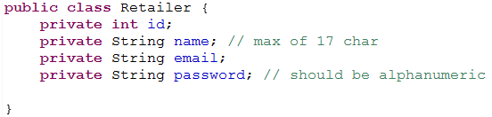

Project Structure:-

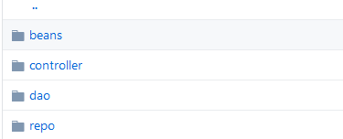

|  |  |  |  |  |  |
| --- | --- | --- | --- | --- | --- |
| Order Id | Product Name | Price Per Unit | Quantity | Amount Payable | Retailer ID |
| ------------ | P1 | 56 | ------------- | -------------- | -------------- |
| ------------ | P2 | 87 | ------------- | --------------- | --------------- |
| ------------ | P3 | 72 | --------------- | ---------------- | --------------- |

Orders Structure:-

*Note:*

1. *You need to use Spring and Hibernate for creating the above application.*
2. *Use DAO Design pattern for DB Interactions.*
3. *On successful login it should go to home page.*
4. *If invalid credentials are given then display proper error message using custom exceptions.*
5. *After 3 unsuccessful attempts account should be locked and on the 4th attempt it should display the message as “Account has been locked. Please Contact System”*
6. *When the account is locked, after one hour if the user tries again to login then it should allow the user to go to home page if the credentials are proper.*